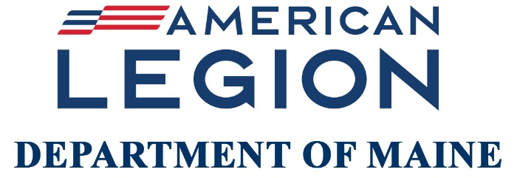

2026 Annual State Convention
Jeff’s Catering & Event Center, Brewer | June 12-13, 2026

The 2026 Annual State Convention of The American Legion, Department of Maine, will be held at Jeff’s Catering & Event Center, 15 Littlefield Way, Brewer, ME 04412. Department Commander Leroy McKenzie will call the Convention to order promptly at noon, Friday, June 12.

Please see attached Member/Guest Registration and Post Delegate/Alternate Registration forms.

If you are an elected Delegate/Alternate, please fill out the POST DELEGATE/ALTERNATE FORM only, and NOT the MEMBER/GUEST REGISTRATION FORM. If you are not a Delegate/Alternate, please fill out the Member/Guest Registration form.

YOUR NAME SHOULD ONLY APPEAR ON ONE FORM. THE FEE PER PERSON IS $10.

Please note: All award recipient family members do not have to register to attend the State Convention.

Electronic Submissions: For those who wish to pay registration online, please follow the steps below. Otherwise, continue to fill out the necessary form(s). Print and mail form(s) along with a check made payable to The American Legion, Dept. of Maine, 5 Verti Drive, Winslow, ME 04901-0727.

- Fill out the required registration form(s) below.
- Save & email the file as an attachment to legionme@mainelegion.org
- Scan the QR Code below with your phone or click on the PAY REGISTRATION link to submit payment electronically.
- Select the number of people registering. (Note: If you are paying online, you will be required to cover the cost of the fees associated with this online transaction.)
- Proceed with payment. Please note that you do not need a PayPal account to pay by Venmo, Debit, or Credit Card.

For up-to-date information regarding State Convention, please visit www.mainelegion.org and click on STATE CONVENTION located under the NEWS & EVENTS dropdown menu.

THE AMERICAN LEGION
DEPARTMENT OF MAINE

POST DELEGATES AND ALTERNATES TO THE 2026 STATE CONVENTION

Following are the elected delegates and alternates for this Post to the 107th Annual State Convention of The Maine American Legion to be held at Jeff’s Catering & Event Center, Brewer on June 12-13, 2026. Election of delegates has been in accordance with the Call to State Convention. All Delegates and Alternates are required to pay a registration fee of $10. This $10 fee will also cover both sessions to be held June 12-13. PLEASE DO NOT FILL OUT THE MEMBER/GUEST REGISTRATION FORM IF YOU ARE AN ELECTED DELEGATE OR ALTERNATE. This form must be electronically submitted if paying online (see instructions above) or mailed to the Department Adjutant’s office by June 1, 2026. The 1976 State Convention mandated that all delegates MUST register before voting. Evidence of registration will be requested by the credentials committee.

By typing your name below, you are signing this form electronically. You agree that your electronic signature is equivalent to your signature.

_______________________________ ________________________________
Post Adjutant's Signature Post Commander's Signature

Delegates |  | Alternates
1. |  | 1.
2. |  | 2.
3. |  | 3.
4. |  | 4.
5. |  | 5.
6. |  | 6.
7. |  | 7.
8. |  | 8.
9. |  | 9.
10. |  | 10.

DELEGATES-AT-LARGE: (Department Officers, Past Department Commanders, and District Commanders)

1.

2.

3.

The Credentials Committee will meet on June 13, 2026, at 8:00 a.m. Registration fee of $10 for each delegate and alternate MUST be paid either electronically (see instructions above) or by mailing a check payable to The American Legion, 5 Verti Drive, Winslow, Maine, ME 04901-0727 by June 1, 2026. ALL DELEGATES MUST BE PRE-REGISTERED.

NAME OF POST ____________

LOCATION ______ POST NO. _____

No. of delegates allowed (Office Use Only)

Member/Guest Registration
(Member is NOT a delegate or alternate)
Please DO NOT fill out the Member/Guest Registration form if you are a Delegate, Alternate, or Delegate-At-Large.

If you are planning to attend the convention this year, all guests and members are required to pay a registration fee of $10. The registration fee covers both sessions to be held June 12-13. Each member and/or guest will receive a name tag upon arrival.

Member/Guest Registration Form
$10.00/Person
First Name |  | Last Name | Member  () | Guest  () | Post No.
1.
2.
3.
4.
5.
6.
7.
8.
9.
10.
Please mail Member/Guest Registration Form and check payable to The American Legion, Dept. of Maine earmarked “Member/Guest Registration” to: The American Legion, Dept, of Maine,
5 Verti Drive, Winslow, Maine 04901-0727 by June 1.

Those who wish to register online, please follow the instructions listed on page 1


*Forms are also available by visiting: www.mainelegion.org/pages/formsapplications.php
PAY REGISTRATION
Scan the QR Code with your phone to pay the Registration Fee or click the PAY REGISTRATION button.

